

Document Type | Revised masters mini-dissertation template
Policy Version | 01.3/2022
Document Version | V4_e_f
Approved By | Senate
Date of Approval | 3 March 2022
Date of Implementation | 1 April 2022
Policy Renewal | March 2025
Policy Custodian | Quality Office and Committee

Using this template
The purpose of this template is to guide Regenesys masters students in formatting and writing their mini dissertations so that we have uniformity in presentation. It is, therefore, expected that all masters’ students adhere to this format in the submission of their work.
[The proposals should also adopt the same chapter style, even though the proposals will end with Chapter Three, and do not require the approval, statement of originality, dedication, or acknowledgment pages. There are separate proposal templates available for qualitative and quantitative research designs. But, the info given in this document can assist with the proposal writing.]
Your submission will begin with the cover page (currently page 5) and you will delete the preceding content, as well as the guidelines within the template on what to cover in each section of the paper.

Document style notes
References
Use APA referencing format in text, your references and your bibliographies. You will receive a comprehensive guide to APA referencing as part of our workshop series, and can access it on the portal at https://portal.regenesys.net/course/view.php?id=18.
Appendices or annexures
Put all information not accommodated in your text into the appendix of, or annexures to, your paper. This includes very long tables that ought to have appeared in the text, your questionnaire, copies of ethical review approval, etc.
Formatting
- Start every chapter on a new page.
- Place page numbers at the bottom of pages.
- Font size: 12
- Spacing: 1.5 spacing, except bibliography where single spacing is required.
- Use these heading styles:
  - Level 1 for the main heading of a chapter
  - Level 2 for headings within a chapter,
  - Level 3 for subsections of anything under a Level 2 heading.
For example:

Chapter 1 (Level 1)

1.0 Background (Level 2)

1.1 International perspectives (Level 2)

1.1.1 The Americas (Level 3)

1.1.1 Europe (Level 3)

Tables:
- Put the table number and title at the top of each table (APA style)
- Keep the number of decimal points used consistent

Table 1
Percentage of Students from Different Faculties
Faculty | Number of Students | Percent (%)
Agriculture | 50 | 25.0
Education | 40 | 20.0
Science | 65 | 32.5
Social science | 45 | 22.5
Total | 200 | 100.0

- Figures:
  - Put the figure number and title at the top of each figure (APA style)

Figure 1
Showing the Percentage of Students per Faculty
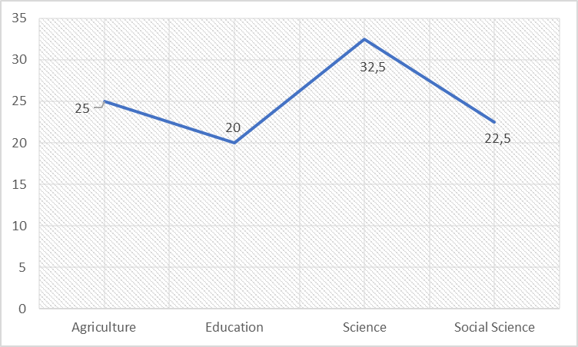
The Regenesys logo and following details should appear on your cover page:

TITLE OF RESEARCH

by
Full Name of Student
Student Number

Supervisor’s(s’) Name (s)

This mini-dissertation is submitted to Regenesys Business School in partial fulfilment of the requirement for the award of the degree of Master of Public Administration/Master of Business Administration (accounting, finance, etc) (delete details that do not apply to you).

APPROVAL
This research project has been examined, and is approved as meeting the required standards of scholarship for potential fulfilment of the requirements for the degree of Master of Public Administration/Master of Business Administration (delete details that do not apply to you).

Signature................................................ ……………………………..
Supervisor 1 Date

Signature................................................ ………………………..........
Supervisor 2 Date

Signature................................................ …….……………………….
Head of Research Date

Signature................................................ …….………………………
Internal examiner Date

Signature................................................ …….……………………….
External examiner Date

STATEMENT OF ORIGINALITY

I, ……… ……….., herewith declare that this DISSERTATION for the Regenesys Business School Master of Public Administration/Master of Business Administration degree has not been submitted for degree purposes at this or any other institution previously. This dissertation is my original work in design and execution, and contributions from other sources have been duly acknowledged (delete details that do not apply to you).

………………………………………… …………………………….
Student’s signature Date

ABSTRACT
Your abstract is a key component of your dissertation. It is the first substantive and clear description of your work that readers, including the external examiner, will see. It provides your first opportunity to set accurate expectations about your dissertation.
The abstract summarises the whole dissertation, presenting all the major elements of your work in a highly condensed form. It can, with the dissertation title, be published as a stand-alone text. Your abstract should be capable of substituting for the whole dissertation when there is insufficient time for the full text to be read. It is, therefore, important that you spend time polishing your abstract. It should summarise:

- The background and problem statement of the study
- Research questions or objectives
- The theoretical or conceptual framework relating to the study
- Data collection and analysis techniques applied in the study
- Main results and recommendations
- Emergent argument

Your abstract should not exceed one and a half pages. Bear in mind that the primary goal of your thesis (and by extension your abstract) is not to explain to readers what you did, but rather to inform them of what you discovered in your study. The second half of the abstract should be dedicated to summarising and interpreting your results.

ACKNOWLEDGEMENTS

DEDICATION

ACRONYMS AND ABBREVIATIONS

TABLE OF CONTENTS
Approval v
Statement of originality vi
Abstract vii
Acknowledgements viii
Dedication ix
Acronyms and abbreviations x
Table of contents xi
List of tables xiii
List of figures xiv
CHAPTER 1: INTRODUCTION AND BACKGROUND 1
1.1 Introduction 1
1.2 Background to the study 1
1.3 Statement of the problem 1
1.4 Research questions 2
1.5 Research objectives 2
1.6 Research hypotheses 3
1.7 Rationale/Motivation/Justification for the study 3
1.8 Significance of the study 4
1.9 Assumptions of the study 4
1.10 Limitations of the study 4
1.11 Delimitation of the study 5
1.12 The theoretical foundation 5
1.13 Theoretical/conceptual framework 5
1.14 Summary of the chapter 6
CHAPTER 2: LITERATURE REVIEW 7
CHAPTER 3: RESEARCH METHODOLOGY 8
3.1 Introduction 8
3.2 Research paradigm and orientation 8
3.3 Research approach 8
3.3.1 Research approach to data collection 9
3.3.2 Research approach in data analysis 9
3.4 The quantitative or qualitative strand in research approach 9
3.4.1 Coverage of the study 9
3..4.2 Target population 10
3.4.3 Sample size calculation 10
3.4.4 Research design 11
3.4.5 Sampling methods 11
3.4.6 Data collection methods 11
3.4.7 Instrument for data collection 12
3.4.8 Pilot study 12
3.4.9 Validity and reliability 13
3.4.10 Administration of research instruments 13
3.4.11 Ethical considerations 13
3.4.12 Procedure for hypotheses testing 13
3.4.13 Measurements 14
3.5 Summary of the chapter: 14
CHAPTER 4: DATA ANALYSIS 15
4.1 Introduction 15
CHAPTER 5: DISCUSSION OF FINDINGS 17
5.1 Introduction 17
CHAPTER 6: SUMMARY AND RECOMMENDATIONS 18
6.1 Summary of the findings 18
6.2 Recommendations 18
6.3 My contributions to knowledge 18
6.4 Published articles from the thesis (if any) Error! Bookmark not defined.

References 19

LIST OF TABLES
Table 1 Percentage of Students from Different Faculties iii
Table 2 Methods of Data Collection 12

LIST OF FIGURES
Figure 1 Showing the Percentage of Students per Faculty iii
Figure 2 Bloom’s Taxonomy 2

CHAPTER 1: INTRODUCTION AND BACKGROUND

1.1 Introduction
This section, usually about one and a half pages, should provide an introduction to what your study is about and the organisation of the entire paper. It should provoke interest and encourage the reader to engage with the paper. This section must answer the question “why” – why is the study valid? What contribution does it add? You will expand on this under the problem statement.

1.2 Background to the study
This section provides the background to the research problem and highlights key gaps that emphasise the need to investigate and solve the problem, the urgency of finding or contributing to a solution, and how you intend to address these gaps. You should demonstrate the perspective of your study in relation to international, regional, and local contexts. In other words, how is the problem you wish to examine seen internationally, regionally, and locally?

1.3 Statement of the problem
This section describes the research problem, which is the axis around which the study revolves. The research problem statement must be clearly formulated, with a clear need to address the problem from a practical and or theoretical perspective. The problem under investigation should not be related to a phenomenon or an issue that is straightforward and unproblematic; that would not warrant an investigation. A mere description cannot be regarded as research. As such, not all problems are viable for scientific research. Your problem statement should answer the following questions: “Why is this study a problem that needs investigation?” “Who are the likely beneficiaries of this study?” “How will the study benefit them?”
You will need to have done an extensive literature review to be able to define the research problem clearly. Almost all aspects (objectives or research questions, methodology) of your paper rely on what you state as the research problem, which must be researchable.

1.4 Research questions
The research questions are derived from the research problem. By answering the research questions, the researcher should be able to address the research problem. The research questions also ensure that the research objectives, which specify and guide what the researcher is going to do, are researched correctly. In other words, answers to the research questions will help realise the research objectives.

1.5 Research objectives
The research objectives are derived from the research problem, and the questions interrogate what the study seeks to achieve. They should be directly linked to the research problem, rephrasing the research questions to explain clearly how the questions are to be answered. They are prefaced by the words “to assess”, “to critically evaluate”, “to analyse”, etc, conforming with the higher levels of Bloom’s Taxonomy. Each research objective must have a related research question seeking to achieve it.
Figure 2
Bloom’s Taxonomy
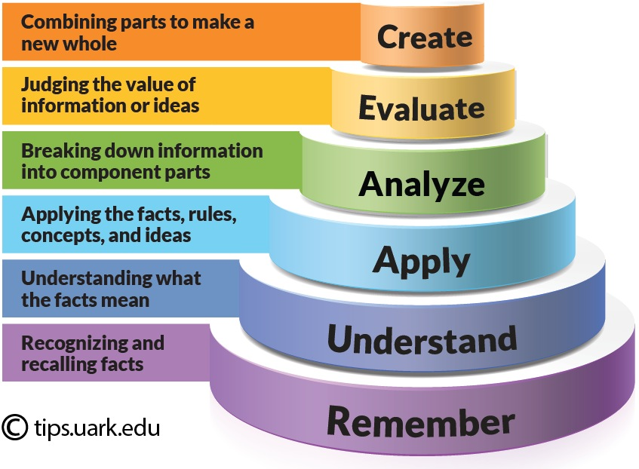
(Source: Shabatura, J., 2013)
Additionally, research questions and objectives are stated in terms of measurable (or easily definable) variables. They must be clear, simple, and relate directly to what needs to be studied or investigated. Using technical terms that may not have been defined in the background will complicate the objectives. The variables to be studied, usually defined in your conceptual framework, come into play in your research questions or objectives.

1.6 Research hypotheses
Your research hypotheses (if applicable) should relate to the research problems, objectives, and questions.
Hypotheses are tentative, testable statements about the relationship between two or more variables and are used in quantitative discourse (study). Whereas research questions do not offer speculative answers relating to the research topic (problem), hypotheses provide guesses about how the research problem might be resolved. In the case of a hypothesis, the research data will either support or not support the guess.
You must ensure that there is a clear link between the problem statement, research objectives, research questions and the hypotheses. In stating your research hypotheses, remember that there are always two statements that go side by side: the null hypothesis (denoted H_{o}) and the alternative hypothesis (denoted by H₁ or H_{A}). The alternative hypothesis represents your view or standpoint – for example, there is a significant association or relationship between A and B – while the null hypothesis tries to state otherwise: “There is no significant relationship between A and B.” Both should be stated for each issue on which a hypothesis is needed.
Note: Hypotheses are used only in quantitative research.

1.7 Rationale/motivation/justification for the study
The rationale for your study is your reason for conducting the study. You may have been motivated to carry out the study by discussions you had with someone, a write-up, your observation of a certain phenomenon, or by reading articles. Your rationale should explain to your reader the need for conducting the study. It justifies the significance and genuineness of the study. The rationale should also explain why the gaps you identified in the literature on your topic should be addressed.

1.8 Significance of the study
The significance of your study is the importance of the study. Here you should highlight how your study will benefit the group you are studying, an organisation, or society in general, and how your study will contribute to solving the broader problem in your field. Your significance statement should also be able to answer questions such as:
- Why should your research be published?
- How will this study contribute to the development of your field?
In other words, the significance of your study should answer the questions: Who are the beneficiaries of the study? How will the study benefit them? And how will the study help future studies in your field?

1.9 Assumptions of the study
In this section state the assumptions that underlie your study.

1.10 Limitations of the study
The limitations of a study are its potential weaknesses. They are usually out of your control, and are closely related to the research design chosen, statistical model constraints, funding constraints, or other factors. They may affect the study design, results, and ultimately, your conclusions. They address the question: what issues might affect the outputs, results, or interpretation of your research results? For example, an unrepresentative sample, choice of time of data collection, etc. State how you hope to, or have, overcome each limiting factor so that your results are reliable. It is better to identify and acknowledge the shortcomings of your study instead of leaving them to be pointed out by your assessors. While discussing your research limitations, don’t just list and describe the shortcomings of your work; explain how these limitations affected your findings and what you did to minimise their effect on the results.

1.11 Delimitation of the study
Delimitations are choices made by the researcher consciously in terms of what to include or exclude in the research to make the study manageable and the aims and objectives achievable. They concern not as much as “why I did this” but rather “why I did not do it like this”. These should be explained and justification provided. For instance, if the delimitation refers to choice of a particular sampling technique, the reasons might be related to available resources, local circumstances (practical access), ethical and permit considerations or time constraints.

1.12 The theoretical foundation
A theoretical foundation is a formal, peer-reviewed theoretical model (or models) that can be used to explain the issue driving your research. The theoretical foundation of your study will certainly embrace one or more theories that can help you explain your study. Search the literature for the theories that appropriately explain the issues in your research topic. Relevant theories must be identified, justified, and explained with respect to their implications for the proposed study.

1.13 Theoretical/conceptual framework
Grant and Osanloo (2014) stated that “the theoretical framework is the foundation from which all knowledge is constructed (metaphorically and literally) for a research study. It serves as the structure and support for the rationale for the study, the problem statement, the purpose, the significance, and the research questions. The theoretical framework provides a grounding base, or an anchor, for the literature review, and most importantly, the methods and analysis.”
In the absence of a theory, you can set out a conceptual framework that includes the structure of concepts and variables you intend to operationalise to achieve the objectives of the study. In particular, relationships among variables should be identified and presented graphically (for quantitative approach). The theoretical framework that forms part of the study should include theoretical perspectives (such as perspectives on motivation, leadership, etc) to help explain the situation you face (your problem) and that underlie the research.
Where applicable, both a theoretical and conceptual framework can be presented.

1.14 Summary of the chapter
Provide a summary of the key issues of Chapter 1 in this section.

CHAPTER 2: LITERATURE REVIEW
The second chapter of your dissertation is the literature review. It critically analyses existing literature related to the chosen research topic and describes previous research on the topic. The aim is to identify gaps and weaknesses in current literature, and possible contributions. Your literature review should clearly identify any international, regional, and local work already done on the identified problem.
In this section, insight should be provided on the research topic, research problem, research questions, research objectives, and hypotheses. The literature review clearly describes how you will contribute to the existing body of knowledge in the particular field of study. Remember that the literature review continues throughout your study.
Consider breaking up your review into themes that reflect the various objectives or research questions. That way, you are able to specifically address issues in each objective in the review.
Remember, the level of your review of the literature, to a large extent, determines your understanding and application of the research topic. Ensure you embark on an extensive literature review before starting your study, and ensure that the literature review is framed by the objectives of the study.
Fundamental to the development of a literature review is the need to identify the gaps in the literature pertaining to the study. Failure to identify the gaps in the literature will declare your study null and void; it indicates no need for the study in the first place.
Close this chapter with a summary of the key issues raised in it.

CHAPTER 3: RESEARCH METHODOLOGY
This is a vital section of your dissertation. People will want to know how you carried out your research to arrive at the conclusions you did. Here you should provide a detailed description of your research methodology. Important aspects include:

3.1 Introduction
This section introduces the content of this chapter.

3.2 Research paradigm and orientation
The research paradigm enables the researcher to examine the methodological aspects of the research project to determine which research methods will be appropriate for collection and analysis of the data. The paradigm can be described in terms of the philosophy of the research in relation to four elements: epistemology, ontology, methodology, and axiology, which comprise the basic assumptions, beliefs, norms, and values each paradigm holds. Discuss each of these as part of your research paradigm and orientation.

3.3 Research approach
Chetty (2016) defined the research approach as a plan and procedure covering the broad assumptions, methods of data collection, analysis, and interpretation.
The research approach to any study is based on the nature of the research problem that the study addresses. It is divided into two broad categories: (i) the approach of data collection, and (ii) the approach of data analysis or reasoning.
Research approaches are methods of investigation to be used (quantitative, qualitative, mixed, multi methods). Your approach should address the questions: “What is the nature of the study: quantitative, qualitative or mixed methods?” and “How will I collect and analyse the data?”

3.3.1 Research approach to data collection
This section discusses the method of data collection that can be used for quantitative or qualitative methods – for example, for qualitative data, in-depth interviews, observation, participant observation, focus group discussions; for quantitative data: survey-administration of interview questionnaire face to face, by post, e-mail, WhatsApp, telephone, Zoom, internet, etc – to test the stated hypotheses, observations and experiments .

3.3.2 Research approach in data analysis
Similarly, this section discusses the methods that you will use to analyse quantitative and qualitative data – for example, deductive approach for quantitative data, and inductive approach for qualitative data; descriptive or inferential statistics for quantitative data; thematic, ethnographic, phenomenology, or grounded theory for qualitative data. The choice of approach should be properly justified.

3.4 The quantitative or qualitative strand in research approach
Depending on whether your study adopts a purely quantitative, purely qualitative, or mixed-method approach (combined quantitative and qualitative approaches), discuss the quantitative or qualitative strands for your study covering the subsections: coverage of the study, target population, sample size calculation (for quantitative research only), research design, sampling method, identification of the study units, instrumentation for the study, pilot study, reliability and validity of the instrument, ethical considerations, data collection, and data analysis.

3.4.1 Coverage of the study
In this section provide the areas (locations) where your study is situated, with short descriptions.

3.4.2 Target population
The target population refers to the entire set of units, individuals, items or objects you intend to conduct research on and draw conclusions or inferences from. Thus, the target population defines the units for which the findings of the survey are intended to generalise. The sampling frame (a list of all items or units in a population) is derived from the target population. You must define your target population because your sample size will be derived from this, and discuss the characteristics of the population from which the sample will be drawn. If you know the size of the target population it is important to state it.

3.4.3 Sample size calculation (for quantitative study only)
The sample is a subset or part of the target population. The sample size represents the number of units, individuals, items, and objects selected from the target population for a study. Effort should be made to calculate the sample size rather than choosing it arbitrarily. The Cochran method of calculating sample size can be used.
The Cochran formula:
Where:
is the sample size
e is the desired level of precision (ie the margin of error),
p is the (estimated) proportion of the population that has the attribute in question,
q is 1 – p.
The z-value is found in a Z table based on a given level of significance, α.
Note that sample sizes for qualitative studies are usually small, and this calculation may not be necessary.

3.4.4 Research design
Research design is a framework of research methods and techniques you can employ in a study. While the research problem dictates the chosen design, the design you select determines the methods suitable for the study. The design of research can be qualitative, quantitative, or mixed, for which you can choose any of the following research methods: experimental studies, surveys (cross-sectional, case study, descriptive), or correlational studies. Research design includes various sampling methods and tools to collect data, so you must also identify which design is appropriate for your study, and justify your choice.

3.4.5 Sampling methods
Probability and nonprobability sampling are methods of selecting a study sample so that it is representative of the population. Probability sampling methods include simple random sampling, stratified (random) sampling, systematic sampling, and cluster sampling. Nonprobability sampling includes purposive sampling, convenience sampling, quota sampling, snowball sampling, and response-driven sampling. Qualitative studies use purposive sampling, and the sample need not be representative. It is important that you justify the suitability of your selected sampling method. The discussion here should include the sampling method you can use to identify individual participants for the study.

3.4.6 Data collection methods
There are a number of ways to collect data. You must discuss fully, with justification, the appropriate method(s) that you used in your data collection.
Choices appropriate for quantitative and qualitative studies are set out in Table 2.

Table 2
Methods of Data Collection
Study type | Methods of data collection | Tools to be used
Quantitative | Surveys | Questionnaires (structured)
Quantitative | Experiments | Field or laboratory observations
Quantitative | Interviews: face-to-face, through post, telephone, email, WhatsApp, zoom, etc. | Questionnaires (structured)
Quantitative | Direct observations | Recording number events as they take place
Quantitative | Documents and records, | Consulting existing records and literature (UN documents, statistical abstracts, census data etc)
Qualitative | Focus groups | Semistructured questionnaire
Qualitative | In-depth interviews | Unstructured interview guide or questionnaire
Qualitative | Participant observations | Unstructured interview guide
Qualitative | Documents and records | Extracting required information
Qualitative | Thematic analysis | Semistructured or unstructured interview guide
Qualitative | Phenomenology | Semistructured or unstructured interview guide
Qualitative | Ethnography | Semistructured or unstructured interview guide
Qualitative | Grounded theory | Semistructured or unstructured interview guide

3.4.7 Instrument for data collection
As shown in Table 1, the instruments for your study can be structured questionnaires, semistructured interview guides, unstructured interview guides, observations, etc.

3.4.8 Pilot study
Note that the essence of a pilot study is to test whether your instrument can be understood by the participants, time allocated for each interview, and test other administrative protocols that might be involved in the research process. Show here how you conducted the pilot for your study, indicating where it was conducted, the sample used, and other procedures used to complete the pilot study. Document the outcomes of the pilot study.

3.4.9 Validity and reliability
Discuss how you ensure that your instruments are valid and reliable (in the case of quantitative study) or trustworthy (credibility, transferability, dependability or confirmability) in the case of a qualitative study. Show how you calculated the reliability coefficient.

3.4.10 Administration of research instruments
Here, explain how the research instrument is administered to the participants, eg face-to-face, telephone, online, internet, post, or e-mail. Ensure that ethical procedures for your selected methods are observed during the administration, and state clearly how this was done.

3.4.11 Ethical considerations
Ethical considerations represent appropriate ways in which research can be conducted so as to ensure that you, as the researcher, (a) behave according to appropriate ethical standards; (b) consider how the research might not negatively affect participants; and (c) protect yourself, your supervisors, and the institution from claims from individuals for inappropriate behaviour during the research, resulting in public criticism or even being sued (Fouka & Mantzorou, 2011). Discuss in this section how you will ensure that participation is voluntary, obtain informed consent, ensure anonymity and confidentiality in the data collection process, and that there is no harm done to the participants. Specify the ethical boards that have approved your study.

3.4.12 Procedure for hypothesis testing
If your study involves hypothesis testing, specify the hypothesis or hypotheses you wish to test, and identify the dependent and independent variables and the inferential statistics that you will use to test them.

3.4.13 Measurements
Scales used in the study (eg Likert, Thurstone)
Availability of previously validated scales
Sample scales or measurements to be used (if available or optional for the proposal)
3.5 Summary of the chapter
Summarise key issues covered in this chapter.

CHAPTER 4: DATA ANALYSIS
This chapter is critical. Your data analysis helps you to make enlightened and credible decisions about your research. Whether you are using a quantitative, qualitative, or mixed-method approach; once you have collected your data, select an appropriate statistical analytical method for your data analysis.

4.1 Introduction
Your introduction to this chapter must link the previous chapter to what you want to do in this one. The other sections will align with the different analyses you carry out.
The analysis you do will depend on whether your data are quantitative or qualitative.
For quantitative data, use descriptive or inferential statistics to analyse and interpret your data.
Descriptive statistics include mean, median, mode, kurtosis, skewness, percentages, correlation coefficient, standard deviation, and variance.
Inferential statistics include the t-test, Z-test (normal distribution), chi-square, F-test (used in the analysis of variance tests).
If your data requires fitting some models you might consider using:
- Linear regression (for two variables, dependent and independent, with the dependent variable continuous); or multiple regression (where you have one dependent and many independent variables).
- Logistic regression (where the dependent variable has two categories – dichotomous, for example: yes, no; defective or nondefective).
- Multinomial logistic regression (where the dependent variable has two or more categories, for example: yes, no, don’t know, etc). Note that the model that will fit your data is determined by the type of data you have. Models cannot be chosen arbitrarily.
For qualitative data, you can use thematic analysis, coding, phenomenological and ethnographical analysis using coding, grounded theory analysis, identification of patterns; identification of outliers, triangulation, etc.
Close this chapter with a summary of the key issues raised in it.

CHAPTER 5: DISCUSSION OF FINDINGS
In this chapter the findings from your analysis in Chapter 4 are discussed and interpretations provided. The discussions are related to the theory that informed the study. The results are compared with those in the literature to see whether they agree with the earlier results. The discussion should align with your objectives or research questions. This will make it easier for your readers to ascertain how you achieved the objectives of the study.
5.1 Introduction
Provide a short introduction to this chapter, and include the objectives of the study. The following sections will depend on how you arranged your data analysis.
Close this chapter with a summary of the key issues raised in it.

CHAPTER 6: SUMMARY AND RECOMMENDATIONS
Here provide a summary of the results of the study, along with recommendations, if any. Recommendations must be based purely on the findings and discussion. Avoid recommending action that is not based on your research findings.
It is also important that you state areas of further research flowing from results you think need further investigation.
Finally, this chapter should contain statements showing your main contribution to knowledge based on the results of your study. Thus you can have the following sections:

6.1 Summary of the findings

6.2 Recommendations

6.3 My contributions to knowledge

References
Grant, C., & Osanloo, A. (2014). Understanding, Selecting and Integrating a Theoretical Framework. In Dissertation Research: Creating the Blueprint for Your “House”. Administrative Issues Journal: Connecting Education, Practice, and Research, Vol 4(2):12-26.
Shabatura, J. (2013). Using Bloom’s Taxonomy to Write Effective Learning Objectives. Assignments & Measuring Student Learning. https://tips.uark.edu/using-blooms-taxonomy/.

